**Oracle SQL Developer Audit Report**

**Student**: Patrick Walsh

**School**: University of Maryland Global Campus

**Date**: 5/3/2021

**Course**: SDEV 350 7380

**Professor**: Reggie Haseltine

1. **How many updates and deletes were performed by each user you created for each table?**

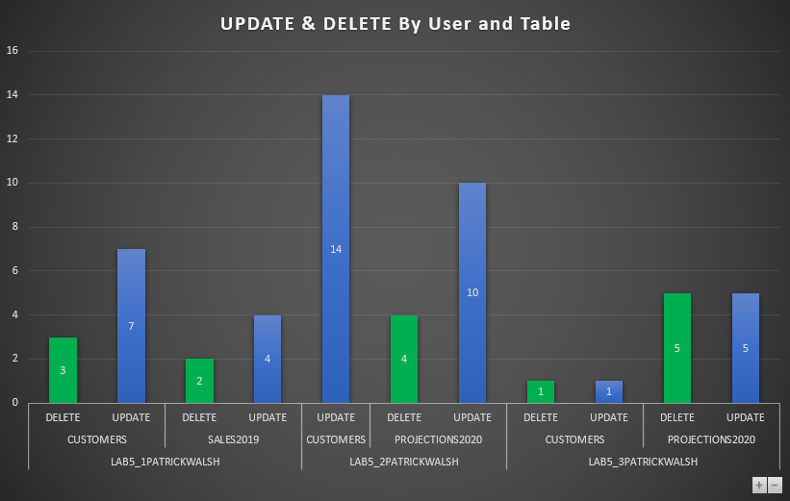

The chart shows the breakdown of UPDATE and DELETE actions for each user on each table. For user LAB5_1PATRICKWALSH, they carried out 3 DELETE statements and 7 UPDATE statements on the Customers table, 2 DELETE statements and 4 UPDATE statements on the Sales2019 table, and so on. We see that user LAB5_2PATRICKWALSH had the most UPDATE actions of any user.

1. **An x,y plot of the times each transaction was completed by each user on the Projections2020 table.**

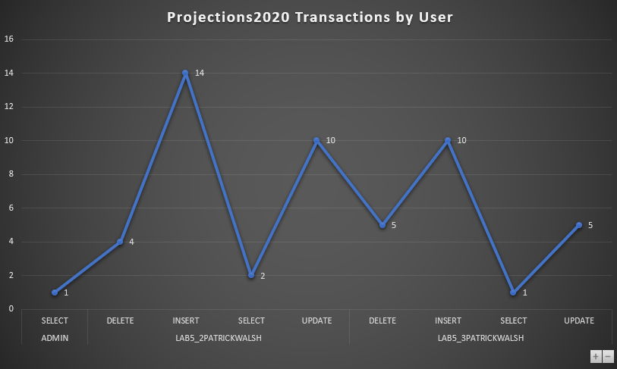

We see that there were three users that had query transactions/statements on the Projections2020 table: Admin, LAB5_2PATRICKWALSH, and LAB5_3PATRICKWALSH. The Admin user only had 1 transaction on this table in the form of a SELECT statement. We also see that the LAB5_2PATRICKWALSH user had many transactions on this table, with 4 DELETE statements, 14 INSERT statements, 2 SELECT statements, and 10 UPDATE statements.

1. **A sequential list of SQL statements used against the Customers table for each user along with the timestamps.**

The following table shows the User, the Timestamp of the activity, and the Action taken for the Customers table. It is arranged in sequential order by Timestamp starting with the oldest datetime and ending in the most recent.

**User Actions Timeline for Customers table**

|  |  |  |
| --- | --- | --- |
| **User** | **Timestamp** | **Action** |
| ADMIN | 03-MAY-21 02.08.08.206720000 PM AMERICA/NEW_YORK | SELECT |
| ADMIN | 03-MAY-21 03.54.47.122526000 PM AMERICA/NEW_YORK | SELECT |
| ADMIN | 03-MAY-21 04.37.24.122001000 PM AMERICA/NEW_YORK | SELECT |
| ADMIN | 03-MAY-21 04.37.38.634819000 PM AMERICA/NEW_YORK | SELECT |
| LAB5_1PATRICKWALSH | 03-MAY-21 04.37.44.043115000 PM AMERICA/NEW_YORK | SELECT |
| LAB5_1PATRICKWALSH | 03-MAY-21 04.38.11.802297000 PM AMERICA/NEW_YORK | INSERT |
| LAB5_1PATRICKWALSH | 03-MAY-21 04.38.11.845649000 PM AMERICA/NEW_YORK | INSERT |
| LAB5_1PATRICKWALSH | 03-MAY-21 04.38.26.300369000 PM AMERICA/NEW_YORK | SELECT |
| LAB5_1PATRICKWALSH | 03-MAY-21 04.38.30.025322000 PM AMERICA/NEW_YORK | INSERT |
| LAB5_1PATRICKWALSH | 03-MAY-21 04.38.30.071429000 PM AMERICA/NEW_YORK | INSERT |
| LAB5_1PATRICKWALSH | 03-MAY-21 04.39.03.811250000 PM AMERICA/NEW_YORK | SELECT |
| LAB5_1PATRICKWALSH | 03-MAY-21 04.39.06.608605000 PM AMERICA/NEW_YORK | INSERT |
| LAB5_1PATRICKWALSH | 03-MAY-21 04.39.06.639231000 PM AMERICA/NEW_YORK | INSERT |
| LAB5_1PATRICKWALSH | 03-MAY-21 04.40.26.829570000 PM AMERICA/NEW_YORK | SELECT |
| LAB5_1PATRICKWALSH | 03-MAY-21 04.40.29.595577000 PM AMERICA/NEW_YORK | INSERT |
| LAB5_1PATRICKWALSH | 03-MAY-21 04.40.29.651130000 PM AMERICA/NEW_YORK | INSERT |
| LAB5_1PATRICKWALSH | 03-MAY-21 04.41.33.772984000 PM AMERICA/NEW_YORK | INSERT |
| LAB5_1PATRICKWALSH | 03-MAY-21 04.41.33.801902000 PM AMERICA/NEW_YORK | INSERT |
| LAB5_1PATRICKWALSH | 03-MAY-21 04.48.59.626755000 PM AMERICA/NEW_YORK | SELECT |
| LAB5_1PATRICKWALSH | 03-MAY-21 04.49.03.427374000 PM AMERICA/NEW_YORK | INSERT |
| LAB5_1PATRICKWALSH | 03-MAY-21 04.49.03.466285000 PM AMERICA/NEW_YORK | INSERT |
| LAB5_1PATRICKWALSH | 03-MAY-21 04.49.52.333249000 PM AMERICA/NEW_YORK | SELECT |
| LAB5_1PATRICKWALSH | 03-MAY-21 04.59.39.789336000 PM AMERICA/NEW_YORK | UPDATE |
| LAB5_1PATRICKWALSH | 03-MAY-21 05.00.01.994418000 PM AMERICA/NEW_YORK | DELETE |
| LAB5_1PATRICKWALSH | 03-MAY-21 05.00.28.392506000 PM AMERICA/NEW_YORK | INSERT |
| LAB5_1PATRICKWALSH | 03-MAY-21 05.00.28.429898000 PM AMERICA/NEW_YORK | INSERT |
| LAB5_1PATRICKWALSH | 03-MAY-21 05.01.39.290123000 PM AMERICA/NEW_YORK | INSERT |
| LAB5_1PATRICKWALSH | 03-MAY-21 05.01.39.316325000 PM AMERICA/NEW_YORK | INSERT |
| ADMIN | 03-MAY-21 05.06.59.309960000 PM AMERICA/NEW_YORK | INSERT |
| LAB5_1PATRICKWALSH | 03-MAY-21 05.07.05.537430000 PM AMERICA/NEW_YORK | INSERT |
| LAB5_1PATRICKWALSH | 03-MAY-21 05.07.05.577117000 PM AMERICA/NEW_YORK | INSERT |
| LAB5_1PATRICKWALSH | 03-MAY-21 05.09.22.735481000 PM AMERICA/NEW_YORK | INSERT |
| LAB5_1PATRICKWALSH | 03-MAY-21 05.13.15.796383000 PM AMERICA/NEW_YORK | INSERT |
| LAB5_1PATRICKWALSH | 03-MAY-21 05.13.15.828347000 PM AMERICA/NEW_YORK | INSERT |
| LAB5_1PATRICKWALSH | 03-MAY-21 05.13.24.297108000 PM AMERICA/NEW_YORK | INSERT |
| LAB5_1PATRICKWALSH | 03-MAY-21 05.13.41.285836000 PM AMERICA/NEW_YORK | INSERT |
| LAB5_1PATRICKWALSH | 03-MAY-21 05.13.58.839946000 PM AMERICA/NEW_YORK | SELECT |
| LAB5_1PATRICKWALSH | 03-MAY-21 05.14.52.292415000 PM AMERICA/NEW_YORK | INSERT |
| LAB5_1PATRICKWALSH | 03-MAY-21 05.15.07.236286000 PM AMERICA/NEW_YORK | INSERT |
| LAB5_1PATRICKWALSH | 03-MAY-21 05.15.07.253585000 PM AMERICA/NEW_YORK | INSERT |
| LAB5_1PATRICKWALSH | 03-MAY-21 05.15.21.897057000 PM AMERICA/NEW_YORK | INSERT |
| LAB5_1PATRICKWALSH | 03-MAY-21 05.15.26.940078000 PM AMERICA/NEW_YORK | INSERT |
| LAB5_1PATRICKWALSH | 03-MAY-21 05.15.30.979429000 PM AMERICA/NEW_YORK | INSERT |
| LAB5_1PATRICKWALSH | 03-MAY-21 05.15.33.948800000 PM AMERICA/NEW_YORK | INSERT |
| LAB5_1PATRICKWALSH | 03-MAY-21 05.15.37.364308000 PM AMERICA/NEW_YORK | INSERT |
| LAB5_1PATRICKWALSH | 03-MAY-21 05.15.43.565099000 PM AMERICA/NEW_YORK | UPDATE |
| LAB5_1PATRICKWALSH | 03-MAY-21 05.15.46.114236000 PM AMERICA/NEW_YORK | UPDATE |
| LAB5_1PATRICKWALSH | 03-MAY-21 05.15.47.962345000 PM AMERICA/NEW_YORK | UPDATE |
| LAB5_1PATRICKWALSH | 03-MAY-21 05.15.49.326013000 PM AMERICA/NEW_YORK | UPDATE |
| LAB5_1PATRICKWALSH | 03-MAY-21 05.15.50.718300000 PM AMERICA/NEW_YORK | UPDATE |
| LAB5_1PATRICKWALSH | 03-MAY-21 05.15.51.987934000 PM AMERICA/NEW_YORK | UPDATE |
| LAB5_1PATRICKWALSH | 03-MAY-21 05.15.56.821032000 PM AMERICA/NEW_YORK | DELETE |
| LAB5_1PATRICKWALSH | 03-MAY-21 05.15.58.828835000 PM AMERICA/NEW_YORK | DELETE |
| LAB5_1PATRICKWALSH | 03-MAY-21 05.17.37.489913000 PM AMERICA/NEW_YORK | SELECT |
| LAB5_1PATRICKWALSH | 03-MAY-21 05.18.25.429730000 PM AMERICA/NEW_YORK | INSERT |
| LAB5_1PATRICKWALSH | 03-MAY-21 05.18.28.536101000 PM AMERICA/NEW_YORK | INSERT |
| LAB5_1PATRICKWALSH | 03-MAY-21 05.18.40.585875000 PM AMERICA/NEW_YORK | SELECT |
| LAB5_2PATRICKWALSH | 03-MAY-21 05.20.00.234644000 PM AMERICA/NEW_YORK | SELECT |
| LAB5_2PATRICKWALSH | 03-MAY-21 05.20.14.583329000 PM AMERICA/NEW_YORK | SELECT |
| LAB5_2PATRICKWALSH | 03-MAY-21 05.20.20.425046000 PM AMERICA/NEW_YORK | INSERT |
| LAB5_2PATRICKWALSH | 03-MAY-21 05.20.23.565678000 PM AMERICA/NEW_YORK | INSERT |
| LAB5_2PATRICKWALSH | 03-MAY-21 05.20.27.219189000 PM AMERICA/NEW_YORK | INSERT |
| LAB5_2PATRICKWALSH | 03-MAY-21 05.20.43.329943000 PM AMERICA/NEW_YORK | UPDATE |
| LAB5_2PATRICKWALSH | 03-MAY-21 05.20.45.158299000 PM AMERICA/NEW_YORK | UPDATE |
| LAB5_2PATRICKWALSH | 03-MAY-21 05.20.47.340559000 PM AMERICA/NEW_YORK | UPDATE |
| LAB5_2PATRICKWALSH | 03-MAY-21 05.20.48.989888000 PM AMERICA/NEW_YORK | UPDATE |
| LAB5_2PATRICKWALSH | 03-MAY-21 05.20.50.426192000 PM AMERICA/NEW_YORK | UPDATE |
| LAB5_2PATRICKWALSH | 03-MAY-21 05.20.51.849638000 PM AMERICA/NEW_YORK | UPDATE |
| LAB5_2PATRICKWALSH | 03-MAY-21 05.20.53.136151000 PM AMERICA/NEW_YORK | UPDATE |
| LAB5_2PATRICKWALSH | 03-MAY-21 05.23.20.617915000 PM AMERICA/NEW_YORK | SELECT |
| LAB5_3PATRICKWALSH | 03-MAY-21 05.26.47.193081000 PM AMERICA/NEW_YORK | SELECT |
| LAB5_2PATRICKWALSH | 03-MAY-21 05.27.34.589545000 PM AMERICA/NEW_YORK | SELECT |
| LAB5_2PATRICKWALSH | 03-MAY-21 05.27.34.847205000 PM AMERICA/NEW_YORK | INSERT |
| LAB5_2PATRICKWALSH | 03-MAY-21 05.27.34.897276000 PM AMERICA/NEW_YORK | INSERT |
| LAB5_2PATRICKWALSH | 03-MAY-21 05.27.34.936771000 PM AMERICA/NEW_YORK | INSERT |
| LAB5_2PATRICKWALSH | 03-MAY-21 05.27.34.984375000 PM AMERICA/NEW_YORK | UPDATE |
| LAB5_2PATRICKWALSH | 03-MAY-21 05.27.35.002864000 PM AMERICA/NEW_YORK | UPDATE |
| LAB5_2PATRICKWALSH | 03-MAY-21 05.27.35.018238000 PM AMERICA/NEW_YORK | UPDATE |
| LAB5_2PATRICKWALSH | 03-MAY-21 05.27.35.033464000 PM AMERICA/NEW_YORK | UPDATE |
| LAB5_2PATRICKWALSH | 03-MAY-21 05.27.35.049084000 PM AMERICA/NEW_YORK | UPDATE |
| LAB5_2PATRICKWALSH | 03-MAY-21 05.27.35.066119000 PM AMERICA/NEW_YORK | UPDATE |
| LAB5_2PATRICKWALSH | 03-MAY-21 05.27.35.082135000 PM AMERICA/NEW_YORK | UPDATE |
| LAB5_3PATRICKWALSH | 03-MAY-21 05.28.00.702937000 PM AMERICA/NEW_YORK | SELECT |
| LAB5_3PATRICKWALSH | 03-MAY-21 05.28.25.586240000 PM AMERICA/NEW_YORK | INSERT |
| LAB5_3PATRICKWALSH | 03-MAY-21 05.28.33.462164000 PM AMERICA/NEW_YORK | INSERT |
| LAB5_3PATRICKWALSH | 03-MAY-21 05.28.58.756664000 PM AMERICA/NEW_YORK | INSERT |
| LAB5_3PATRICKWALSH | 03-MAY-21 05.29.01.312669000 PM AMERICA/NEW_YORK | INSERT |
| LAB5_3PATRICKWALSH | 03-MAY-21 05.29.02.977240000 PM AMERICA/NEW_YORK | INSERT |
| LAB5_3PATRICKWALSH | 03-MAY-21 05.29.04.406253000 PM AMERICA/NEW_YORK | INSERT |
| LAB5_3PATRICKWALSH | 03-MAY-21 05.29.05.732790000 PM AMERICA/NEW_YORK | INSERT |
| LAB5_3PATRICKWALSH | 03-MAY-21 05.29.18.271878000 PM AMERICA/NEW_YORK | UPDATE |
| LAB5_3PATRICKWALSH | 03-MAY-21 05.29.24.818273000 PM AMERICA/NEW_YORK | DELETE |
| ADMIN | 03-MAY-21 05.58.24.648580000 PM AMERICA/NEW_YORK | SELECT |
| ADMIN | 03-MAY-21 05.58.32.402718000 PM AMERICA/NEW_YORK | SELECT |
| ADMIN | 03-MAY-21 05.58.35.431803000 PM AMERICA/NEW_YORK | SELECT |